**Use Case: Supplier Dashboard**

**Actor:** Supplier

**Use Case Description:** The supplier navigates through the dashboard to get an overview of their business operations, including purchase orders, invoices, inventory, and payments. The dashboard provides insights through various graphical representations, helping the supplier make informed decisions.

**Trigger Point:** The supplier logs into the supplier portal.

**Pre-conditions**:

* The supplier must have an account and be authorized to access the supplier portal.
* The dashboard is updated with the latest data from various business operations.

**Post-conditions:**

* The supplier gains insights into their business operations, helping in decision-making and operational planning.

**Normal Flow:**

1. Login: The supplier successfully logs into the supplier portal.

2. Dashboard Overview: Upon login, the dashboard displays four key information cards:

* Active PO (Purchase Orders)
* Pending Invoices
* Inventory Holding
* Payments Received

3. Invoice: Below the information cards, the dashboard shows a Vertical Bar graph chart representing cleared and uncleared invoices. A "month" filter button allows the supplier to filter the data displayed based on different time frames (Today, This Week, This Month, This Year).

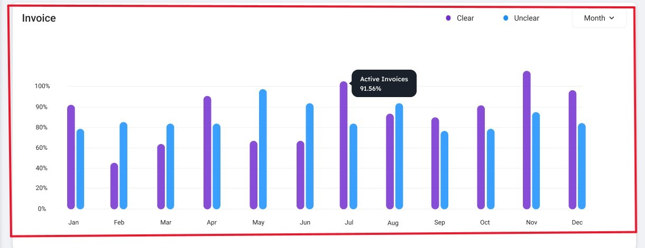

4. Top Sales By Category: In the middle left side of the dashboard, there's a "top sales by category" panel displayed as a doughnut chart. It categorizes sales into various supplies like IT services, Pantry, Subscription, Electronics, Stationary. A "month" button on the right top side of the chart enables filtering based on time.

5. Purchase Order: Next to the sales analysis panel, a Speedometer chart represents Today's Purchase Orders, Previous POs, and Active PO's, with a "month" button for time-based filtering.

6. Payments: At the bottom of the dashboard, a line graph panel shows "Received" and "Pending" payments. A "month" button on the top right side allows for filtering by time period.

**Alternative Flow:**

* Data Update Request: If the supplier notices outdated information, they can request a data refresh or update through the portal, ensuring the dashboard reflects the most current business operations status.
* Customization Request: the supplier may request customization of the dashboard to include additional insights or remove irrelevant sections, tailoring the dashboard to better meet their specific needs.